Cloud Guide
(To help students fill in “Cloud Types” and “Cloud Cover” on Rice Air Curriculum Data Sheets)

Cloud Types
High in the Sky:
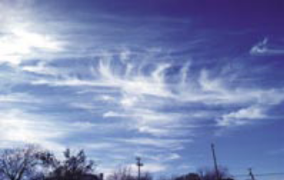 | 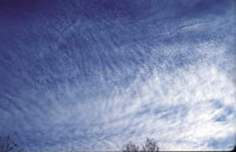 | 
Cirrus | Cirrocumulus | Cirrostratus

Middle of the Sky:
 | 
Altocumulus | Altostratus

Low in the Sky:
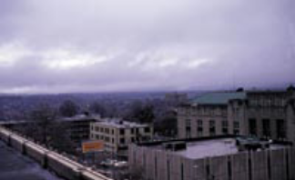 | 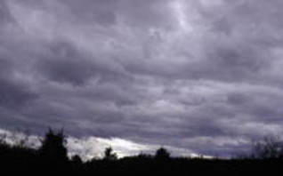 | 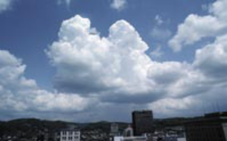
Stratus | Stratocumulus | Cumulus

Rain or Snow Producing Clouds:
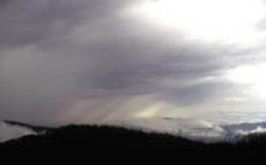 | 
Nimbostratus | Cumulonimbus

Cloud Cover
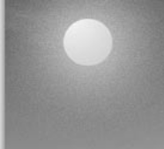 | 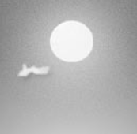 | 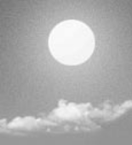 | 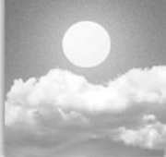 |  | 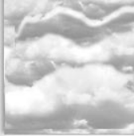
No Clouds | Clear | Isolated | Scattered | Broken | Overcast
0% - No clouds | <10% Clouds | 10-25% Clouds | 25-50% Clouds | 50-90% Clouds | >90% Clouds

